Project 2

Infix Expression parser



11/13/2022

Connor Clawson - Lubaba Masangu - Thanh Dat Nguyen

# Introduction

This project was a collaboration between Connor Clawson, Lubaba Masangu, and Thanh Dat Nguyen. The program takes user input from a text file containing mathematical expressions and performs a calculation for each line in the file.

# Members Contribution

Thanh wrote the operator precedence handler infix to postfix conversion and co-wrote the postfix evaluation. Lubaba wrote the main function, co-wrote the postfix evaluation and handled bug fixes. Connor wrote the input formatter and documentation.

Tasks were distributed amongst the team on a volunteer basis.

# UML Class Diagram

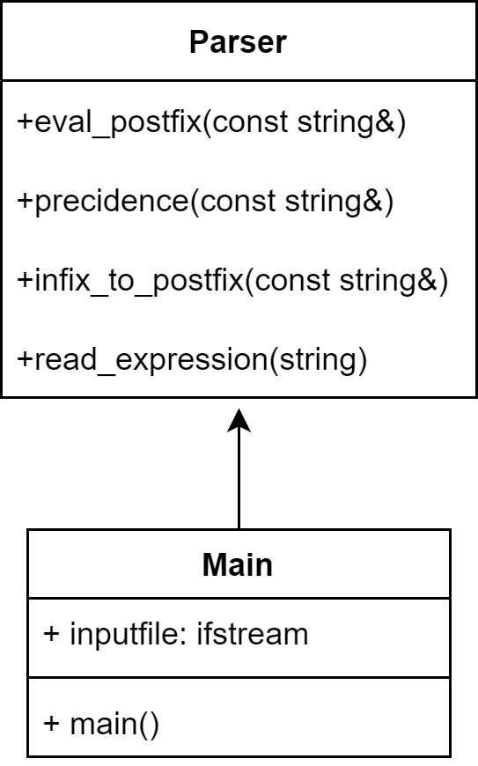

# Test cases

|  |  |  |
| --- | --- | --- |
| Expression string | Expected result | Actual result |
| 2 + 2 | 4 | 4 |
| 3 / (6 * 5 – 30) | Division by zero error | Division by zero error |
| 1+2*3 | 7 | 7 |
| 2+2 ^ 2*3 | 14 | 14 |
| 1 ==2 | 0 (false) | 0 (false) |
| 1+3 > 2 | 1 (true) | 1 (true) |
| (4>=4) && 0 | 0 (false) | 0 (false) |
| (1+2)*3 | 9 | 9 |
| 2%2+2^2-5*(3^2) | -41 | -41 |
| Empty string | Skipped | Skipped |

# Improvements

Connor entertained the idea of adding logarithmic functions. Thanh Dat added to that with possible support for more mathematical functions such as sin, cos, tangents, etc. Lubaba suggested adding support for prefix and post fix expressions.

# GitHub Repository

Repository package is available here:

<https://github.com/CClawsonSCC/SCC-Team-Project-2>